Project Concept
1  Player Control |  | You control a | in this
  Rocket
  top Down | game
1  Player Control |  | where | makes the player
  The mouse/WASD
  Moves the rocket, mouseclick/W will add thrust

2  Basic  Gameplay |  | During the game, | from
  Asteroids, and debris | appear
  The top and sides
2  Basic  Gameplay |  | and the goal of the game is to
  To survive and make it to the end destination, without being destroyed or runniong out of fuel, and not being swallowed by the blackhole on the bottom of the screen, the player can destroy aersteroids for a chance of regaining fuel

3  Sound  & Effects |  | There will be sound effects | and particle effects
  Humming, rocket, sci-fi background music, pews
  hurt sounds, collectible sounds
  Small particle exhaust rocket, debris being destroyed effeccts, blackhole swirls
3  Sound  & Effects |  | [optional] There will also be
  Blackhole will intensify throughout the game, heavier particles

4  Gameplay  Mechanics |  | As the game progresses, | making it
  More asteroids (fewer with fuel crystals, and the blackhole will expand its gravirty
  Harder to avoid aesteroids while also keeping ahead of the event-horizon
4  Gameplay  Mechanics |  | [optional] There will also be
  Power-ups can appear to aid the player in survival (temportary invinciblilty, diffrent types of shooting patterns)

5  User  Interface |  | The | will | whenever
  There will be a score determioned by progression and asteroids destroyed, lives measured inj a healthbar,
  determioned by progression and asteroids destroyed,score will increase, health will decrease by damage
  Damage to the ship will decrease score and health
  longevity and high health will increase score
5  User  Interface |  | At the start of the game, the title |  | and the game will end when
  Escape to the Future | will appear
  The player makes it to the end goal, dies, or fails to avoid the blackhole

6  Other Features
  Splash screen will be of logo and slogan,fun facts will be displayed in the HUD, the ship will resemble the logo of the comany

Project Timeline
Milestone | Description | Due
#1
  Character motion and Test LVL
  02/02
#2
  Simple 2D Graphics
  02/04
#3
  Scoring and UI
  02/06
#4
  Online Scores
  02/09
#5
  Polish
  02/11
Backlog
  - Multiplayer- not a part of the minimum viable product
  N/A

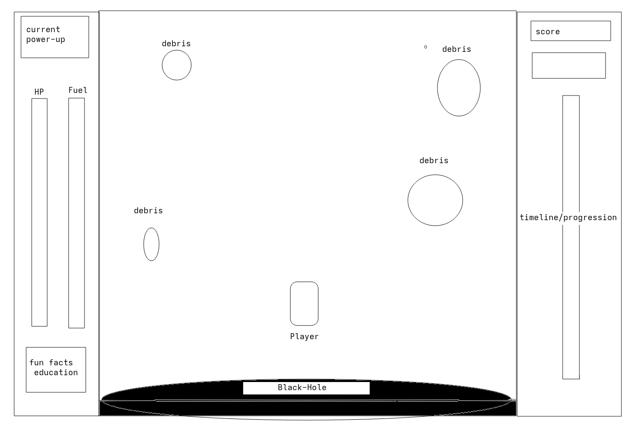

Project Sketch

